
VIETNAM NATIONAL UNIVERSITY – HO CHI MINH CITY
INTERNATIONAL UNIVERSITY

Object-Oriented Programming
(MINI PROJECT)

OUR PROJECT
BATTLE CITY
GAME

I.INTRODUCTION:

1.1 Group Members: + Bùi Đăng Khoa_ITITIU19146

+ Thái Gia Lạc_ITITU19152

LECTURER: Dr. Lê Thành Sơn

LAB LECTURER: Dr. Nguyễn Quang Phú

1.2 History:
Battle City is the 1985 remake of Tank Battalion, another arcade classic from Namco. Both games are nearly exactly alike, except for the fact that Battle City has drastically improved graphics and a few new features. Battle City was also one of the first games to support dual two player game play.
Battle City was subsequently ported to the Game Boy and the Japanese Famicon home gaming console. A sequel to Battle City, named Tank force, debuted in 1991.
1.3 Design Overview :
The project’s purpose is to build the classic video game “Battle City” using Java language. Users should be able to play this 3rd-person multidirectional shooting game using keyboard as controller and monitor for display. The game features single or two user-customizable modes. Differences among these three levels are mainly presented as different moving speed and firing rate. Design software units using Java language for tank generation, movement and application of game rules.
1.4 Game Rules:
The basic rule of the game is that players should control a tank to reach the higher level of game by destroying all the enemy tanks while keeping the home safe from enemy tanks.
There are 20 enemy tanks in total to be generated at random positions on the edge of the game window in the beginning of each game.
With different difficult levels, enemy tanks’ moving speed and fire rate would increase drastically at higher-level games, thus harder for players to win.
The player's tank will be created in a fixed position right next to the home field for each match and will have a total of 200 health to fight the enemy tank, and each shot by the opponent will lose 50 health ( If two bullets collide, it will disappear ).
A player is deemed to have lost the game when they have left zero health or the main house is destroyed by the enemy tank before all levels of the game are over when there are 4 levels to pass.
The player who kills all the enemy tanks wins.
There are 4 obstacles:
+ Metalwall : not to be destroyed by bullets, not to move through
+ Wall : can be destroyed, after destruction can be transferred through.
+ River : can shoot through, but cannot get through.
+ Tree : can shoot past bullets, pass through and become invisible while inside.

II. FUNCTION OF THE GAME:

2.1. The interface and display of the game:

Menu Bar
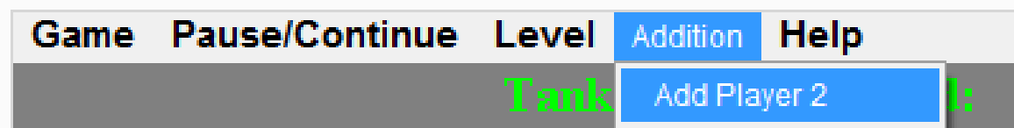

Interface when the game just started the match
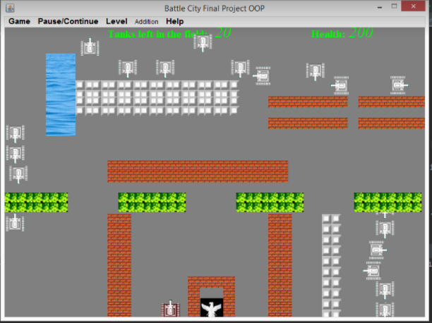

Interface when you win the match
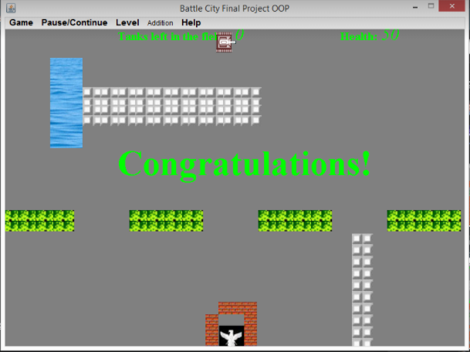

Interface when you lose the match
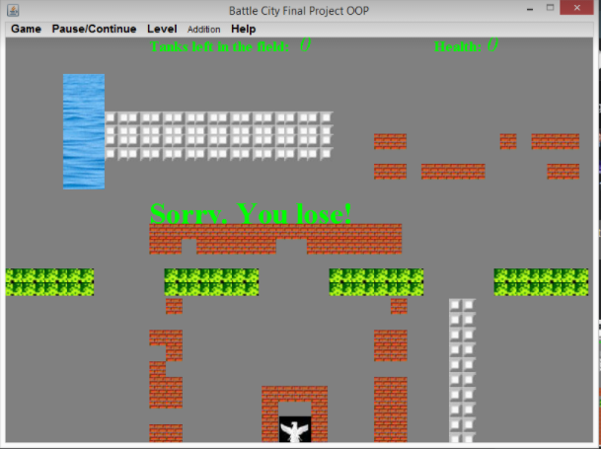

Bullet

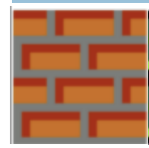

Wall


MetalWall

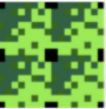

Trees



River



Player's tank 1



Player's tank 2

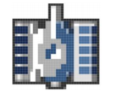

Enemy tank



Home

2.2. Functions of game code:

a) Attack nearby player:

Check if nearby:
public boolean playertankaround(){
int rx=x-15,ry=y-15;
if((x-15)<0) rx=0;
if((y-15)<0)ry=0;
Rectangle a=new Rectangle(rx, ry,60,60);
if (this.live && a.intersects(tc.homeTank.getRect())) {
return true;
}
return false;
}

b) Tank Collisions :

Collision
Two kind of collisions:
Tank collisions
Bullet collisions

- Collide with Wall:
public boolean collideWithWall(CommonWall w) {
if (this.live && this.getRect().intersects(w.getRect())) {
this.changToOldDir();

return true;
}
return false;
}

public boolean collideWithWall(MetalWall w) {
if (this.live && this.getRect().intersects(w.getRect())) {
this.changToOldDir();
return true;
}
return false;
}

Collide with River:
public boolean collideRiver(River r) {
if (this.live && this.getRect().intersects(r.getRect())) {
this.changToOldDir();
return true;
}
return false;
}

Collide with Home:
public boolean collideHome(Home h) {
if (this.live && this.getRect().intersects(h.getRect())) {
this.changToOldDir();
return true;
}
return false;
}

Collide with Tanks:
public boolean collideWithTanks(java.util.List<Tank> tanks) {
for (int i = 0; i < tanks.size(); i++) {
Tank t = tanks.get(i);
if (this != t) {
if (this.live && t.isLive()
&& this.getRect().intersects(t.getRect())) {
this.changToOldDir();
t.changToOldDir();
return true;
}
}
}
return false;
}

c) Bullet Collisions:
- Collide with common wall:
public boolean hitWall(CommonWall w) {
if (this.live && this.getRect().intersects(w.getRect())) {
this.live = false;
this.tc.otherWall.remove(w);
this.tc.homeWall.remove(w);
return true;
}
return false;
}

- Collide with metal wall:
public boolean hitWall(MetalWall w) {
if (this.live && this.getRect().intersects(w.getRect())) {
this.live = false;
return true;
}
return false;
}
- Hit Tank:
public boolean hitTanks(List<Tank> tanks) {
for (int i = 0; i < tanks.size(); i++) {
if (hitTank(tanks.get(i))) {
return true;
}
}
return false;
}
public boolean hitTank(Tank t) {
if (this.live && this.getRect().intersects(t.getRect()) && t.isLive()
&& this.good != t.isGood()) {

BombTank e = new BombTank(t.getX(), t.getY(), tc);
tc.bombTanks.add(e);
if (t.isGood()) {
t.setLife(t.getLife() - 50);
if (t.getLife() <= 0)
t.setLive(false);
} else {
t.setLive(false);
}

this.live = false;

return true;
}
return false;
}
- Hit Wall:
public boolean hitWall(CommonWall w) {
if (this.live && this.getRect().intersects(w.getRect())) {
this.live = false;
this.tc.otherWall.remove(w);
this.tc.homeWall.remove(w);
return true;
}
return false;
}

- Hit Bullet:
public boolean hitBullet(Bullets w){
if (this.live && this.getRect().intersects(w.getRect())){
this.live=false;
this.tc.bullets.remove(w);
return true;
}
return false;
}
- Hit MetalWall:
public boolean hitWall(MetalWall w) {
if (this.live && this.getRect().intersects(w.getRect())) {
this.live = false;
return true;
}
return false;
}
- Hit Home:
public boolean hitHome() {
if (this.live && this.getRect().intersects(tc.home.getRect())) {
this.live = false;
this.tc.home.setLive(false);
return true;
}
return false;
}

2.3. Class Diagram:
